Starting the administrator agent to open administrator GUI and adding

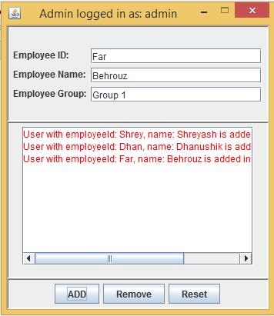

Removing users for the system

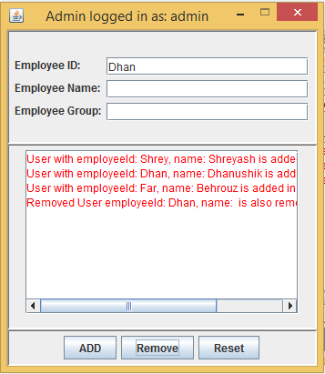

Adding another User with same employeeID, “Dhan”

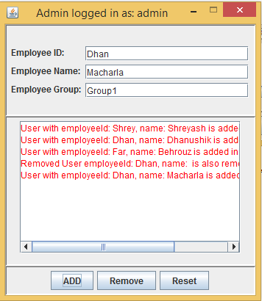

Adding agenda for personal meetings

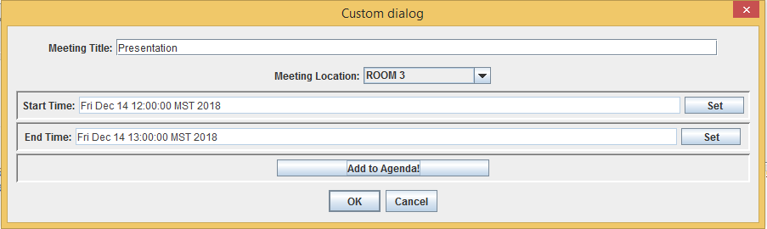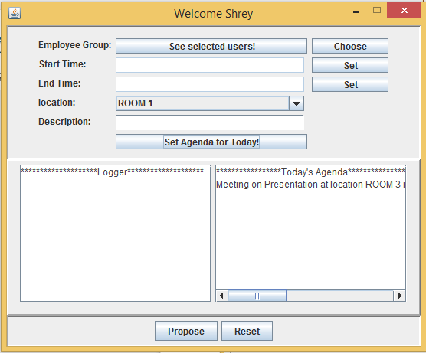

Dhan proposing a meeting to FAR and SHREy

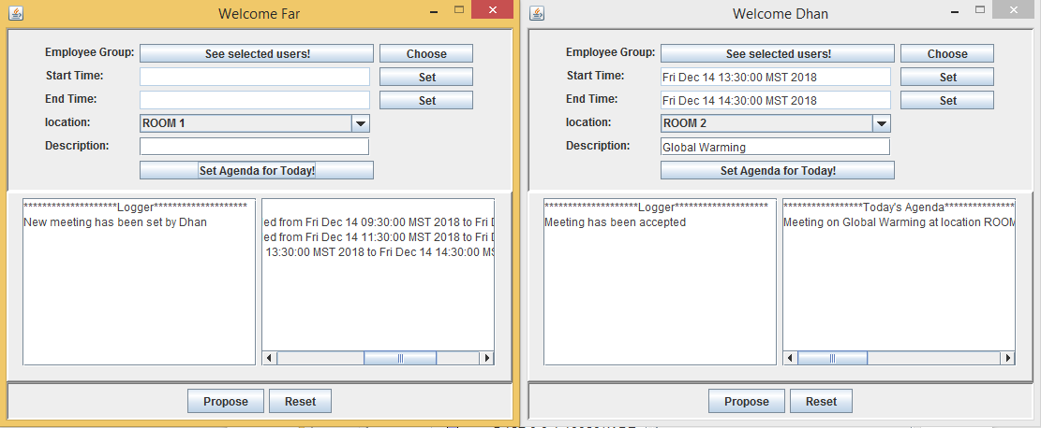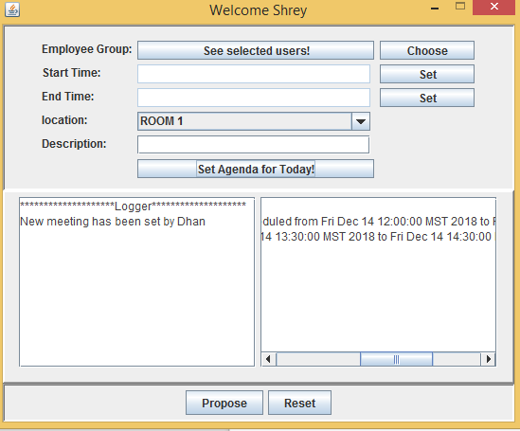Renegotiating time

Far trying to set a meeting from 12:45 to 13:05 but Shrey is not free at that time so meeting manager is recalculating time and checking when all users are free for a slot of 20 minutes and setting it 13:05 to 13:25.

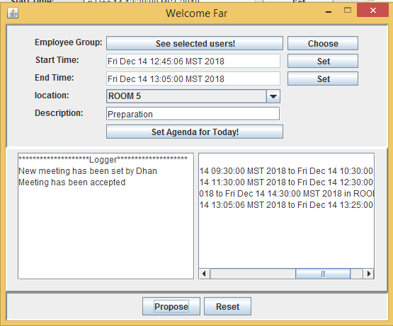

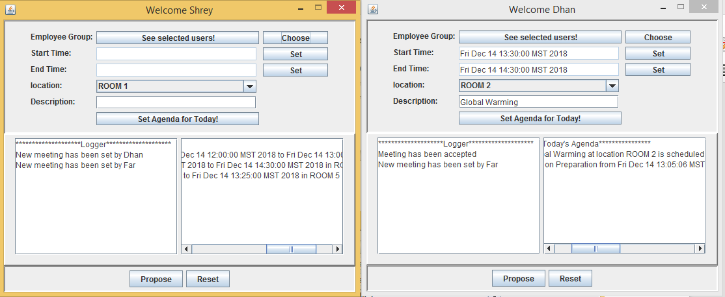

Shrey trying to set a meeting but rejection case

